

The Erudite Guider

**Software Requirement Specification**

**Project Code: TEG**

**Document Code: TEG_SRS – <v0.3>**

**Hanoi, September 19th 2016**

Record of Change

*A - Added M - Modified D - Deleted

|  |  |  |  |  |
| --- | --- | --- | --- | --- |
| Effective Date | Changed Items | A* M, D | Change Description | New Version |
| 19/09/2016 | Create new | A | Create document | 0.1 |
| 11/10/2016 | Section 3.1.6 | M | Change use case name and use case description | 0.2 |
| Section 3.1 | A | Add new functions |
| 1/11/2016 | Section 3.1 | A | Add new functions | 0.3 |
|  |  |  |  |  |
|  |  |  |  |  |
|  |  |  |  |  |
|  |  |  |  |  |
|  |  |  |  |  |
|  |  |  |  |  |
|  |  |  |  |  |
|  |  |  |  |  |
|  |  |  |  |  |
|  |  |  |  |  |
|  |  |  |  |  |
|  |  |  |  |  |
|  |  |  |  |  |
|  |  |  |  |  |
|  |  |  |  |  |
|  |  |  |  |  |
|  |  |  |  |  |
|  |  |  |  |  |

Signature Page

**ATHOR:** Nguyen Huu Quyet Date: 2016/09/19

Project manager

**REVIEWERS:** Mong Quoc Toan Date: 2016/10/07

Member

**APPROVAL:** Bui Đinh Chien Date: 2016/10/29

Supervisor

Table of Contents

Record of Change 2

Signature Page 3

Table of Contents 4

Definitions and Acronyms 6

2 Introduction 7

2.1 Purpose 7

2.2 Scope 7

2.3 References 7

3 System requirements Specification 8

3.1 Functional requirements 8

3.1.1 Use Case Diagram 8

3.1.2 Business rule 9

3.1.3 Register 11

3.1.4 Log in 12

3.1.5 Log out 14

3.1.6 Get new password 15

*3.1.6.1* Forgot password 15

*3.1.6.2* Re- create password 16

3.1.7 Object management 17

*3.1.7.1* Upload new object 17

*3.1.7.2* View object’s information 18

*3.1.7.3* View object’s information: 19

*3.1.7.4* Change object’s information 19

*3.1.7.5* Change object’s information: 20

3.1.8 Search object by name 20

*3.1.8.1* Search object by name 20

3.1.9 Send request 22

*3.1.9.1* Request to change 22

*3.1.9.2* Request to delete 23

3.1.10 View request 24

3.1.11 View museum profile 25

*3.1.11.1* View museum profile: 26

3.1.12 Edit museum profile 26

3.1.13 Choose museum 27

*3.1.13.1* Choose museum: 28

3.1.14 Object scanning- View Object information 29

*3.1.14.1* Object scanning- View Object information: 29

3.2 Screen Prototype 30

3.3 Non-Functional Requirements 31

3.3.1 Security 31

3.3.2 Usability 32

3.3.3 Reliability 32

3.3.4 Performance 32

3.3.5 Maintainability 32

3.3.6 Extendibility 32

3.4 Database Requirements 33

Definitions and Acronyms

|  |  |  |
| --- | --- | --- |
| Acronym | Definition | Note |
| TEG | The Erudite Guider |  |
| SRS | Software Requirement Specification |  |
| QA | Quality Assurance |  |
| PM | Project Manager |  |
| DB | Database |  |
| SC | Screen |  |
| UC | Use Case |  |
| N/A | Not Available |  |
| No. | Number |  |
| GUI | Graphic User Interface |  |

# Introduction

## Purpose

The main purpose of the requirement document is provides the information of the erudite guider project from many perspectives. Readers can find out about the overview description or detail information in this document.

The information is the fully describing about the software system such as functional requirements, non-functional requirements, design constrains and any other necessary information.

This document is the software requirement specification of the erudite guider project in order to develop the software, it includes two main parts: User Requirement Specification and System Requirements Specification:

* User Requirement Specification:
* Provides the general information about the software system.
* The project manager and supervisors should read this part because they can partly base on it to negotiate with each other about some particular problems.
* System Requirements Specification:
* Provides the detail information about the software system. This part captures the complete software requirements for the system, and then it is important for software designer, software developer, machine maker and manufacturer, tester and maintainer.
* This part is also for the project manager because it can help him to monitor all the activities of the project effectively.

## Scope

The document applies to many stages of developing the system:

* It is first used for project manager and supervisors to negotiate.
* It is also very important for designing, developing, manufacturing, testing and maintaining the system:
* The designers must know what the system is and what function it needs to have.
* The developing must know what the system does, how each function is implemented and the interface between components in system.
* The tester must know that to check if the system meets the requirements or not.

## References

Document:

1. TEG_Report_3_SRS_v0.1.pdf, Project Code: TEG, FPT University, Hanoi, Vietnam

# System requirements Specification

## Functional requirements

### Use Case Diagram

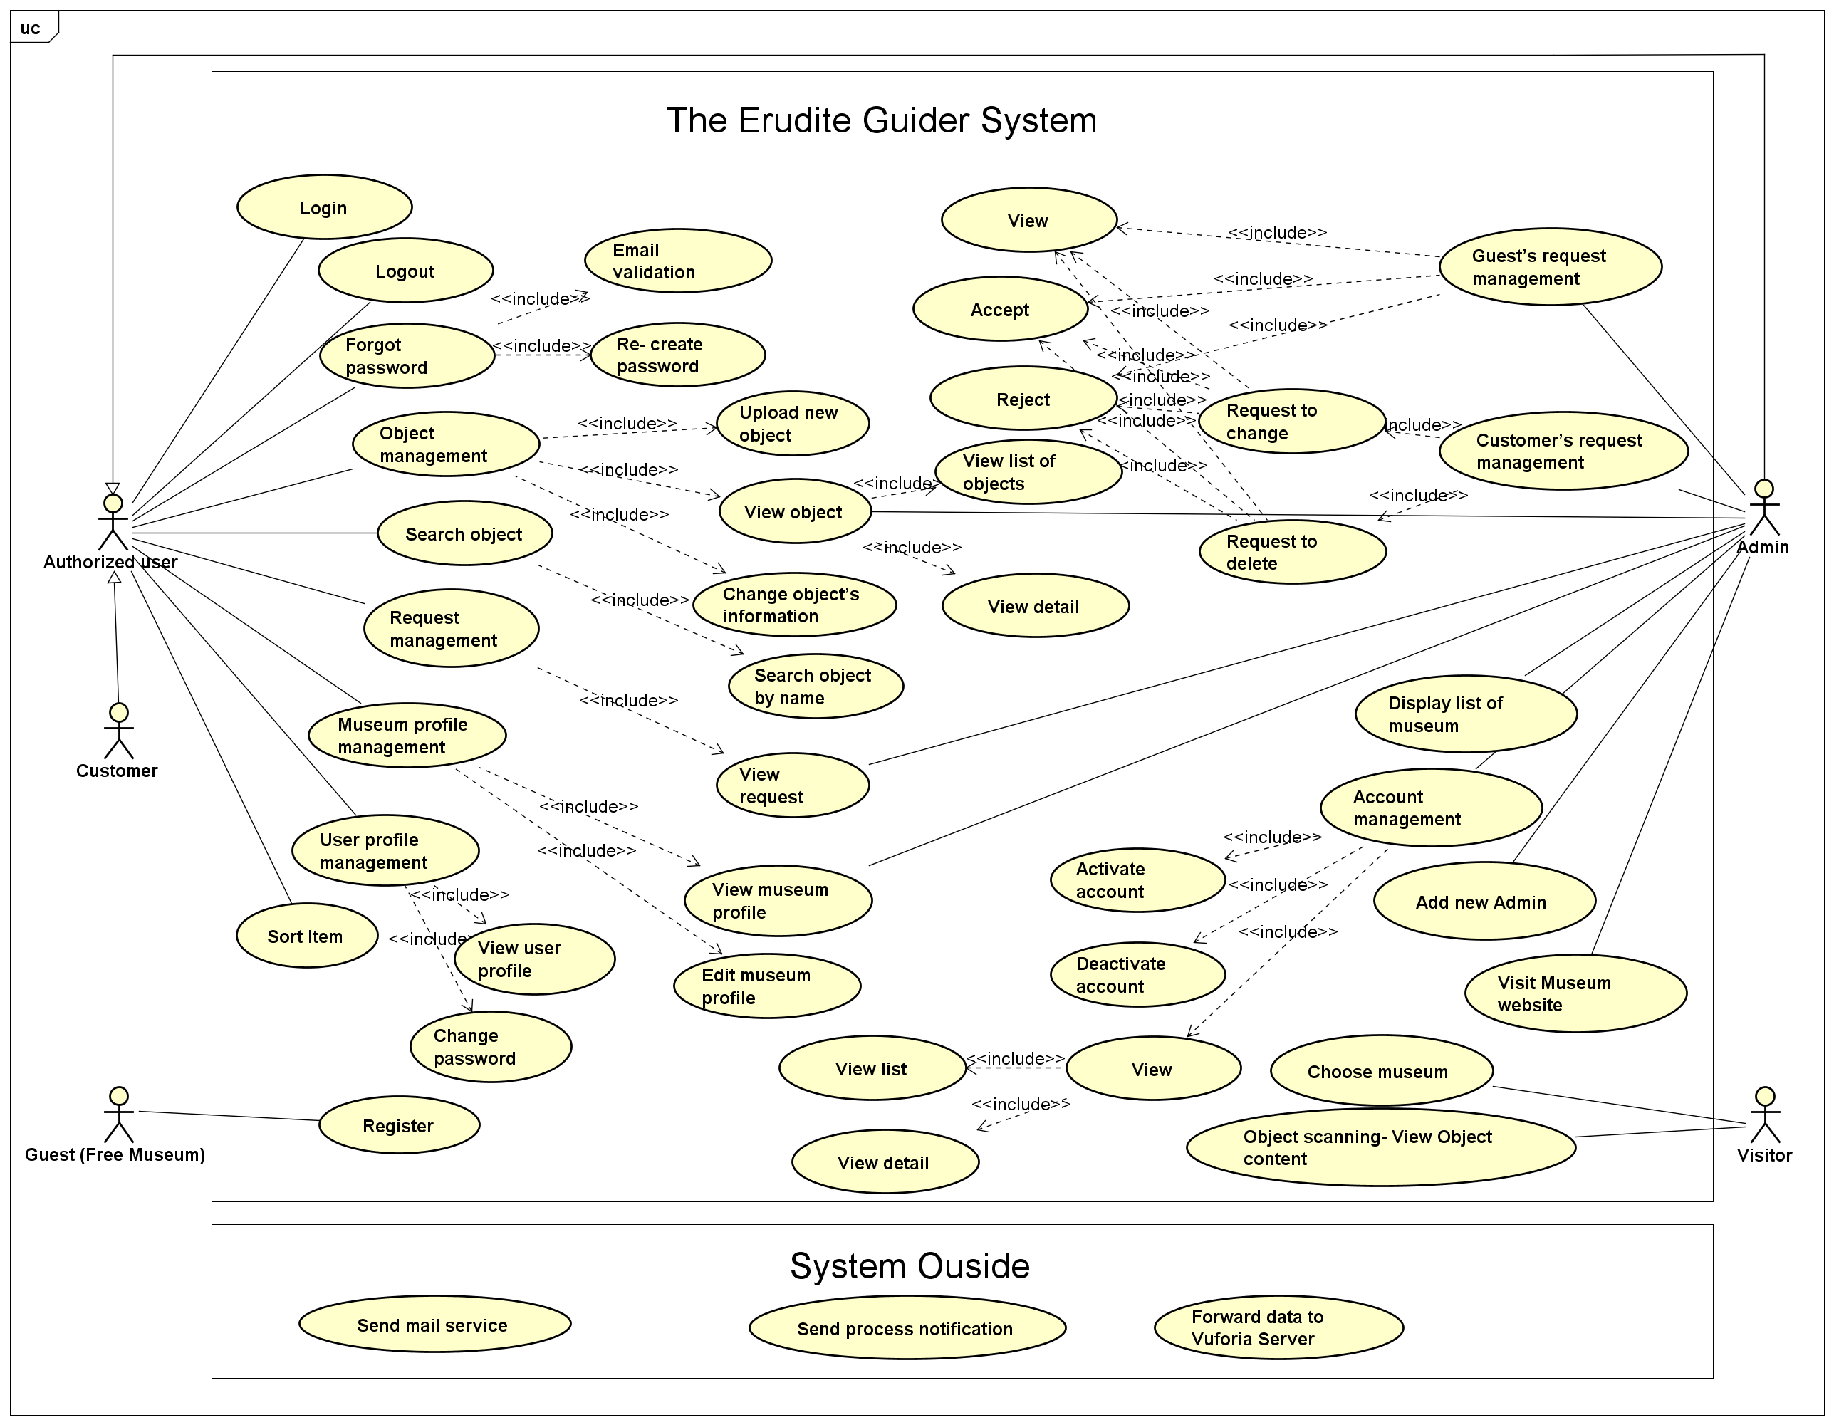

**FIGURE 3-1-1: Use Case Diagram**

TABLE 3-1-1: Actor description

|  |  |  |
| --- | --- | --- |
| No | Actor | Description |
| 1 | Guest (Free Museum) | Museum enterprise that have not become system's member yet. |
| 2 | Customer | Museums that have account as system's member and their staff who take responsibility for “The Erudite Guider” system. |
| 3 | Administrator | A person who has the highest permission level and is responsible for managing accounts, museum, request, … |
| 4 | Visitor | Someone who visit the museum and use mobile application to view object’s information by scan their mobile phone’s camera on objects. |
| 5 | Authorized user | Customer and Administrator. |

TABLE 3-1-2: Use Cases list

|  |  |  |  |  |  |  |  |
| --- | --- | --- | --- | --- | --- | --- | --- |
| No | Actor | Use-case name | | | | | Use-case no |
| 1 | Guest (Free Museum) | Register | | | | | UC-01-01 |
| 2 | Customer  Administrator | Log in | | | | | UC-02-01 |
| 3 | Customer  Administrator | Log out | | | | | UC-03-01 |
| 4 | Customer  Administrator | Forgot password | Email validation | | | | UC-04-01 |
| 5 | Re- create password | | | | UC-04-02 |
| 6 | Customer | Object management | Upload new object | | | | UC-05-01 |
| 7 | Customer  Administrator | View object | | View list of objects | | UC-05-02 |
| 8 | View detail | | UC-05-03 |
| 9 | Customer | Change object’s information | | | | UC-05-04 |
| 10 | Customer  Administrator | Search object by name | | | | | UC-06-01 |
| 11 | Customer | Request management | Send request | | Request to change | | UC-07-01 |
| 12 | Request to delete | | UC-07-02 |
| 13 | Customer  Administrator | View request | | | | UC-07-03 |
| 14 | Customer  Administrator | Museum profile management | View museum profile | | | | UC-08-01 |
| 15 | Customer | Edit museum profile | | | | UC-08-02 |
| 16 | Customer  Administrator | User profile management | View user profile | | | | UC-09-01 |
| 17 | Change password | | | | UC-09-02 |
| 18 | Administrator | Guest’s request management | View | | | | UC-10-01 |
| 19 | Accept | | | | UC-10-02 |
| 20 | Reject | | | | UC-10-03 |
| 21 | Administrator | Customer’s request management | Request to change | | View | | UC-11-01 |
| 22 | Accept | | UC-11-02 |
| 23 | Reject | | UC-11-03 |
| 24 | Request to delete | | View | | UC-11-04 |
| 25 | Accept | | UC-11-05 |
| 26 | Reject | | UC-11-06 |
| 27 | Administrator | Display list of museum | | | | | UC-12-01 |
| 28 | Administrator | Account management | | View | | View list | UC-13-01 |
| View detail | UC-13-02 |
| 29 | Deactivate account | | | UC-13-03 |
| 30 | Activate account | | | UC-13-04 |
| 31 | Administrator | Add new Admin | | | | | UC-14-01 |
| 32 | Customer  Administrator | Sort Item | | | | | UC-15-01 |
| 33 | Administrator | Visit Museum website | | | | | UC-16-01 |
| 34 | Visitor | Choose museum | | | | | UC-17-01 |
| 35 | Visitor | Object scanning- View Object content | | | | | UC-18-01 |

### Business rule

TABLE 3-1-3: Business rule

|  |  |
| --- | --- |
| No | Description |
| B1 | “Địa chỉ email” must not be empty |
| B2 | “Địa chỉ email” must be valid |
| B3 | “Địa chỉ email” length must be in range from 19 to 50 |
| B4 | “Địa chỉ email” must be email and contain character “.” and “@”. |
| B5 | “Mật khẩu” must not be empty |
| B7 | “Mật khẩu” must be valid |
| B8 | “Mật khẩu” length must be in range from 8 to 16 |
| B9 | “Nhập lại mật khẩu” must be matched with “Mật khẩu” |
| B10 | “Tên bảo tàng” must not be empty |
| B11 | “Tên bảo tàng” must be valid |
| B12 | “Tên bảo tàng” length must not be greater than 150 |
| B13 | “Xã/ Phường” must not be empty |
| B14 | “Xã/ Phường” must be valid |
| B15 | “Xã/ Phường” length must not be greater than 30 |
| B16 | “Huyện/ Quận” must not be empty |
| B17 | “Huyện/ Quận” must be valid |
| B18 | “Huyện/ Quận” length must not be greater than 30 |
| B19 | “Tỉnh/ Thành phố” must not be empty |
| B20 | “Tỉnh/ Thành phố” must be valid |
| B21 | “Tỉnh/ Thành phố” length must not be greater than 30 |
| B22 | “Số điện thoại” must not be empty |
| B23 | “Số điện thoại” must be a numeric string only |
| B24 | “Số điện thoại” length must not be greater than 20 |
| B25 | “Địa chỉ website” must be valid |
| B26 | “Tên hiện vật” must not be empty |
| B27 | “Tên hiện vật” must be valid |
| B28 | “Tên hiện vật” length must not be greater than 150 |
| B29 | “Mô tả hiện vật” must not be empty |
| B30 | “Hình ảnh hiện vật” must not be empty |
| B31 | “Hình ảnh hiện vật” image file size must not be greater than 2MB |
| B32 | “Hình ảnh hiện vật” image file’s type must be: “image/png”, “image/jpeg”, “image/gif” or “image/jpg” |
| B33 | “Audio thuyết minh” must not be empty when “Phim tư liệu” is empty |
| B34 | “Audio thuyết minh” audio file size must not be greater than 10MB |
| B35 | “Audio thuyết minh” audio file’s type must be: “audio/mp3” |
| B36 | “Phim tư liệu” must not be empty when “Audio thuyết minh” is empty |
| B37 | “Phim tư liệu” video file size must not be greater than 20MB |
| B38 | “Phim tư liệu” video file’s type must be: “video/mp4” |
| B39 | “Hình ảnh nhận diện” must not be empty |
| B40 | “Hình ảnh nhận diện” image file size must not be greater than 2MB |
| B41 | “Hình ảnh nhận diện” image file’s type must be: “image/png”, “image/jpeg”, “image/gif” or “image/jpg” |
| B42 | A new object have 2 statuses: “PENDING” or “AVAILABLE” |
| B43 | Customer only can change information of object in “PENDING” status |
| B44 | Object in “AVAILABLE” status will automatically become a request to change to “ACTIVE” status |
| B45 | List of object must include of object in 3 status: “PENDING”, “AVAILABLE” and “ACTIVE” for actor is Admin, but only 2 statuses: “PENDING” and “ACTIVE” for actor is Customer |
| B46 | Search bar must not be empty |
| B47 | “Lý do gửi yêu cầu” must not be empty |
| B48 | List of request must include of all kind of request |
| B49 | Admin only accept valid guest’s request |
| B50 | After admin verify guest’s request, notation must be sent to guest’s email |
| B51 | After admin verify customer’s request, notation must be sent to customer’s email |
| B52 | List of museum must only display museums are using The Erudite Guider’s services |
| B53 | Account have 2 statuses: “ACTIVE” and “DEACTIVE” |
| B54 | List of account must include all of status |
| B55 | Account is in “ACTIVE” status |
| B56 | Account is in “DEACTIVE” status |
| B57 | “Trạng thái” include 2 values: “ACTIVE” or “DEACTIVE” |
| B58 | “ACTIVE” or “DEACTIVE” radio button must be checked |
| B59 | Museum in list must be online on system (Using services of The Erudite Guider system) |
| B60 | Objects must be in “ACTIVE” status |
| B61 | Active object is in changing process must has notify for user when it is scanned |
| B62 | Notification must be sent automatically to user’s email. |

### Register

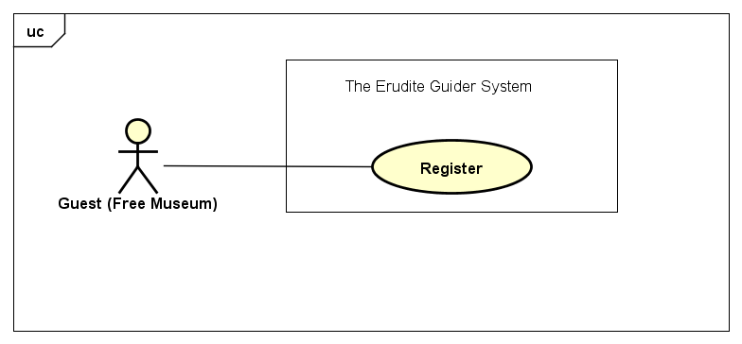

|  |  |  |  |
| --- | --- | --- | --- |
| Use Case ID: | UC-01-01 | | |
| Created By: | QuyetNH | Date Created: | 19/09/2016 |
| Primary Actor: | Guest (Free Museum) | Secondary Actor: | N/A |
| Trigger: | Click on “Đăng ký” on navigation bar. | | |
| Description | When you have just visited *The Erudite Guider*, you are our guest and you can view what our technology and features are, view information of project team. Moreover, to use those unique functions, what you need to do is register an account and then become our member. Our system use museum’s email for account request. When you became a member of our system, as such museum (enterprise), you can easily manage your artifacts, object by add new, change and remove them… The Erudite system allows you to register an account as an enterprise with basic information (museum name, address, account password, email …). And we instantly send you an email to confirm. When you have an account, you can login to *baotang.esy.es* and enjoy the service we bring to your enterprise. | | |
| Preconditions: | Guest has a valid email address and right information of enterprise (museum). | | |
| Post conditions: | Our system will confirm the registration by sending an email to user. | | |
| Normal Flow: | Register:   1. The guest clicks on “Đăng ký” on navigation bar. 2. The guest enters “Địa chỉ email”, ”Mật khẩu”, “Nhập lại mật khẩu”, “Tên bảo tàng”, “Xã/ Phường”, “Huyện/ Quận”, “Tỉnh/ Thành phố”, “Số điện thoại”, “Địa chỉ website”. 3. The guest clicks on “Yêu cầu tài khoản” button. 4. Admin validates all the information. If it is correct, *The Erudite Guider* system will add user information to database and send an email to user’s email address with text: “Yêu cầu của bạn đang được xử lý”. 5. After administrator received guest’s request, he validate the reality of information in that request and decide to approve to create a new account in DB and then notice that museum. | | |
| Alternative Flows: | N/A | | |
| Exceptions: | N/A | | |
| Priority: | High | | |
| Frequency of Use: | Medium. | | |
| Business Rules: | B1, B2, B3, B4, B5, B6, B7, B8, B9, B10, B11, B12, B13, B14, B15, B16, B17, B18, B19, B20, B21, B22, B23, B24, B25 | | |
| Other Information: | N/A | | |
| Assumptions | N/A | | |

### Log in

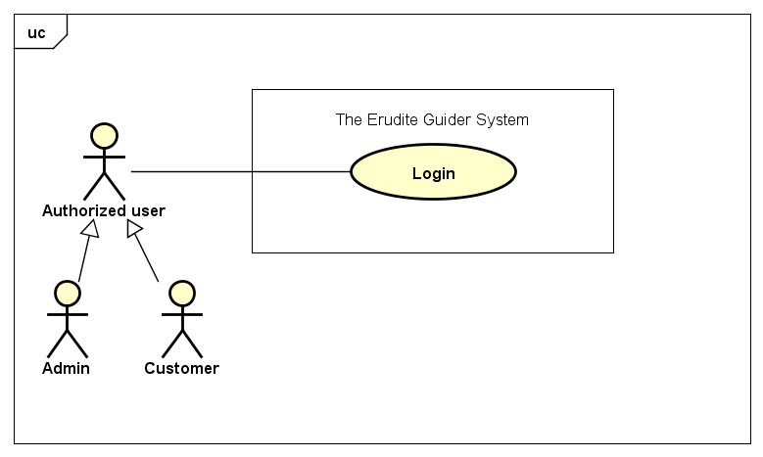

|  |  |  |  |
| --- | --- | --- | --- |
| Use Case ID: | UC-02-01 | | |
| Created By: | QuyetNH | Date Created: | 19/09/2016 |
| Primary Actor: | Authorized user | Secondary Actor: | Customer  Admin |
| Trigger: | Click on “Đăng nhập”on navigation bar. | | |
| Description | Logging in is usually used to enter *The Erudite Guider*, which trespassers cannot see by using your registered account. Once you go to login page and click “Đăng nhập”, our system ask you to enter your email and password in “Địa chỉ email” and “Mật Khẩu” field corresponding. You have to just enter exact username and password that you registered. After logged in successfully, you not only can access to your but also manage your artifact’s information of the museum that you are working in. Moreover, you can interactive to Admin by request to change or remove your artifact on your system as well. | | |
| Preconditions: | User has an account to login to *The Erudite Guider*. | | |
| Post conditions: | N/A | | |
| Normal Flow: | Log in:   1. The actor clicks on “Đăng nhập” on navigation bar. 2. The actor enters: “Địa chỉ email” and “Mật Khẩu”. 3. The actor clicks on “Đăng nhập” button. | | |
| Alternative Flows: | N/A | | |
| Exceptions: | N/A | | |
| Priority: | High. | | |
| Frequency of Use: | High. | | |
| Business Rules: | B1, B2, B3, B4, B5, B6, B7, B8 | | |
| Other Information: | N/A | | |
| Assumptions | N/A | | |

### Log out

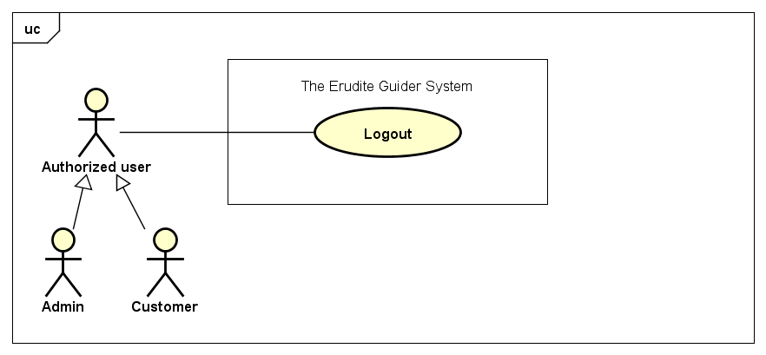

|  |  |  |  |
| --- | --- | --- | --- |
| Use Case ID: | UC-03-01 | | |
| Created By: | QuyetNH | Date Created: | 19/09/2016 |
| Primary Actor: | Authorized user | Secondary Actor: | Customer  Admin |
| Trigger: | Click on “Đăng xuất” in dropdown menu. | | |
| Description | You are our Customer and logging in *The Erudite Guider* system then want to finish your session after you have used our features to manage your work. By click on “Đăng xuất” button, system will terminate your session and now your personal information is protected from any other. Whoever does not have permission or not authorized is impossible to see your works on the system. After log out, you can login again with your museum account anytime.  Logout feature also works similar to admin account. | | |
| Preconditions: | User is in Login status. | | |
| Post conditions: | User is logged out *The Erudite Guider* system. | | |
| Normal Flow: | Log out:   1. Actor clicks on email display on navigation bar. 2. Actor clicks on ““Đăng xuất” in dropdown menu. 3. Actor logged out *The Erudite Guider* system. | | |
| Alternative Flows: | N/A | | |
| Exceptions: | System cannot end user’s session. | | |
| Priority: | Medium. | | |
| Frequency of Use: | High. | | |
| Business Rules: | N/A | | |
| Other Information: | N/A | | |
| Assumptions | N/A | | |

### Forgot password

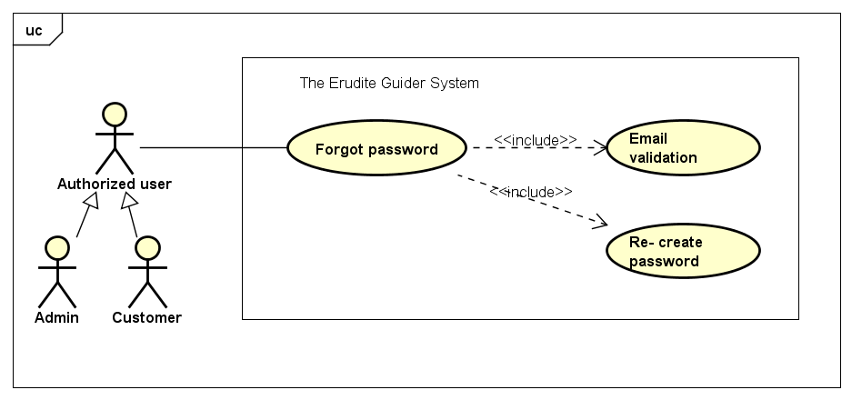

#### Email validation

|  |  |  |  |
| --- | --- | --- | --- |
| Use Case ID: | UC-04-01 | | |
| Created By: | QuyetNH | Date Created: | 19/09/2016 |
| Primary Actor: | Authorized user | Secondary Actor: | Customer  Admin |
| Trigger: | The actor click on “Quên mật khẩu” link. | | |
| Description | Password is a set of secret characters or words utilized to gain access to *The Erudite Guider*. Passwords help ensure that museum’s data can only be accessed by those who have been granted the right to view or access them. Therefore, it is mandatory requirement to login to *The Erudite Guider*. Sometimes, you want re- create the password because you forgot it and cannot get it back. This function will help you easily do that. What you need to do is providing us your valid email that was used to register to our system. Then, system will send a link to that email and you just follow this link. | | |
| Preconditions: | Customer has an account and email address that confirmed the right information of enterprise (museum). | | |
| Post conditions: | Notification will be sent automatically to customer’s email. | | |
| Normal Flow: | Email validation:   1. The actor click on “Quên mật khẩu” link. 2. Enter your right email in “Email của bạn” field. 3. Clicks on “Khôi phục mật khẩu” button. | | |
| Alternative Flows: | N/A | | |
| Exceptions: | System cannot find user’ right email. | | |
| Priority: | High | | |
| Frequency of Use: | Medium. | | |
| Business Rules: | B1, B2, B3, B4, B62 | | |
| Other Information: | N/A | | |
| Assumptions | N/A | | |

#### Re- create password

|  |  |  |  |
| --- | --- | --- | --- |
| Use Case ID: | UC-04-02 | | |
| Created By: | QuyetNH | Date Created: | 19/09/2016 |
| Primary Actor: | Authorized user | Secondary Actor: | Customer Admin |
| Trigger: | Authorized user needs to access to The Erudite Guider system. | | |
| Description | You have just used Email validation and received a link in your email. This link help you confirm your new password that you just reset. Then you want to set the password as the new and your own because you simply want to replace one password to remember. After click on the link, you can set your new password easily. | | |
| Preconditions: | access link that sent to email successfully | | |
| Post conditions: | New password will be created | | |
| Normal Flow: | Re- create password:  1. Authorized user click on the link was sent to their email.  2. Then enter new password in “Mật khẩu mới” text field.  3. Re-enter password in “Nhập lại mật khẩu” text field to confirm it.  4. Then clicks on “Xác nhận” button. | | |
| Alternative Flows: | N/A | | |
| Exceptions: | N/A | | |
| Priority: | Medium. | | |
| Frequency of Use: | Medium. | | |
| Business Rules: | B5, B6, B7, B8, B9 | | |
| Other Information: | N/A | | |
| Assumptions | N/A | | |

### Object management

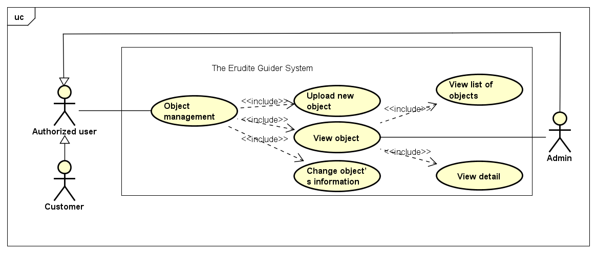

#### Upload new object

|  |  |  |  |
| --- | --- | --- | --- |
| Use Case ID: | UC-05-01 | | |
| Created By: | QuyetNH | Date Created: | 19/09/2016 |
| Primary Actor: | Authorized user | Secondary Actor: | Customer |
| Trigger: | Customer clicks on “Thêm hiện vật” button. | | |
| Description | The main purpose of this system is to help the customer (Museum Admin) manage his/ her object of the corresponding museum. Every single object has its own information and need to be uploaded to the system to make it be visible from mobile application. This function is only available for museum’s staff because only they know what information is exact for museum’s object. Before submit object information, Customer have to verify which status of this information is. We were defined 2 clearly status for this: Pending and available. If pending is checked, this object is saved to system but not ready for system admin verify yet. The customer can change the information only. If available radio button is checked, now the information of the object is saved to system also and now it is sent as a request and ready for system admin can verify it. In this case, customer cannot change it anymore and this object display on request manager screen instead of list of object. | | |
| Preconditions: | Authorized user login to system successfully. | | |
| Post conditions: | N/A | | |
| Normal Flow: | Upload new object:   1. Customer login to *The Erudite Guider* and click on “Quản lý hiện vật” section on left navigation bar. 2. Customer clicks on “Thêm hiện vật” button. 3. Customer provides information of object he/ she want to upload by fill on such as text field: “Tên hiện vật*”, “Mô tả hiện vật*”, “Hình ảnh hiện vật*”, “Audio thuyết minh”, “Phim tư liệu”, “Hình ảnh nhận diện*”. The sign “*” means that field is mandatory. 4. Customer check “Trạng thái” radio button. 5. Click on “Thêm hiện vật” button to finish action. | | |
| Alternative Flows: | N/A | | |
| Exceptions: | Customer can click “Trở lại” button to cancel uploading new object. | | |
| Priority: | High | | |
| Frequency of Use: | High | | |
| Business Rules: | B26, B27, B28, B29, B30, B31, B32, B33, B34, B35, B36, B37, B38, B39, B40, B41, B42, B43, B44 | | |
| Other Information: | N/A | | |
| Assumptions | N/A | | |

#### View object

##### View list of objects

|  |  |  |  |
| --- | --- | --- | --- |
| Use Case ID: | UC-05-02 | | |
| Created By: | QuyetNH | Date Created: | 19/09/2016 |
| Primary Actor: | Authorized user | Secondary Actor: | Customer Admin |
| Trigger: | Customer: “Quản lý hiện vật” section on left navigation bar.  Admin: Click “Tên bảo tàng”. | | |
| Description | After upload new object’s information successfully, Customer can go to “Danh sách hiện vật bảo tàng” to view the list of object belong to corresponding museum. In this screen, customer can see full information of objects have status Pending or Active. Active status means this object’s information is approved by Admin and online on system the system (can be read by mobile app). | | |
| Preconditions: | Museum has at least 1 valid object uploaded. | | |
| Post conditions: | List of objects will be displayed | | |
| Normal Flow: | View list of objects:  1. Customer: 2. Customer login to The Erudite Guider. 3. Click on “Quản lý hiện vật” section on left navigation bar. 4. List of object will be displayed. 5. Admin: 6. Admin login to The Erudite Guider. 7. Click on “Quản lý bảo tàng” section on left navigation bar. 8. Click on “Tên bảo tàng” to see list of object of corresponding museum. | | |
| Alternative Flows: | N/A | | |
| Exceptions: | N/A | | |
| Priority: | High | | |
| Frequency of Use: | High | | |
| Business Rules: | B45 | | |
| Other Information: | N/A | | |
| Assumptions | N/A | | |

##### View detail

|  |  |  |  |
| --- | --- | --- | --- |
| Use Case ID: | UC-05-03 | | |
| Created By: | QuyetNH | Date Created: | 19/09/2016 |
| Primary Actor: | Authorized user | Secondary Actor: | Customer Admin |
| Trigger: | Click on “Tên hiện vật” | | |
| Description | When list of object is displayed, some of main information of object already showed such as: Video, Audio, and Status. Moreover, if want to see more detail about object, authorized user can click on object’s name (link) to go to detail screen. | | |
| Preconditions: | Museum has at least 1 valid object uploaded. | | |
| Post conditions: | Detail of chosen object will be displayed. | | |
| Normal Flow: | View detail:  1. Customer: 2. Customer login to The Erudite Guider. 3. Click on “Quản lý hiện vật” section on left navigation bar. 4. List of object will be displayed. 5. Click on object’s name to see detail information. 6. Admin: 7. Admin login to The Erudite Guider. 8. Click on “Quản lý bảo tàng” section on left navigation bar. 9. Click on “Tên bảo tàng” to see list of object of corresponding museum. 10. Click on object’s name to see detail information. | | |
| Alternative Flows: | N/A | | |
| Exceptions: | N/A | | |
| Priority: | High | | |
| Frequency of Use: | High | | |
| Business Rules: | B45 | | |
| Other Information: | N/A | | |
| Assumptions | N/A | | |

#### Change object’s information

|  |  |  |  |
| --- | --- | --- | --- |
| Use Case ID: | UC-05-04 | | |
| Created By: | QuyetNH | Date Created: | 19/09/2016 |
| Primary Actor: | Authorized user | Secondary Actor: | Customer |
| Trigger: | Click “Sửa” button | | |
| Description | After upload new object’s information successfully, Customer can go to “Danh sách hiện vật bảo tàng” to view the list of object belong to corresponding museum. In this screen, customer can see full information of objects have status Pending or Active. Active status means this object’s information is approved by Admin and online on system the system (can be read by mobile app). With objects have Pending status, customer can directly edit them by click on “Sửa” button if those information not satisfy his/ her expectation yet. Then, customer can change information of that corresponding object he/she clicked on. | | |
| Preconditions: | Museum has at least 1 valid object uploaded. | | |
| Post conditions: | Object’s information is changed. | | |
| Normal Flow: | Change object’s information:  1. Customer login to *The Erudite Guider* and click on “Quản lý hiện vật” section on left navigation bar. 2. List of object available in system will be displayed. 3. Customer click on “Sửa” button to open edit screen. 4. Change information they want and click “Lưu” button. | | |
| Alternative Flows: | Customer click on “Trở lại” button to cancel changing. | | |
| Exceptions: | N/A | | |
| Priority: | High | | |
| Frequency of Use: | Medium | | |
| Business Rules: | B26, B27, B28, B29, B30, B31, B32, B33, B34, B35, B36, B37, B38, B39, B40, B41, B42, B43, B44 | | |
| Other Information: | N/A | | |
| Assumptions | N/A | | |

### Search object by name

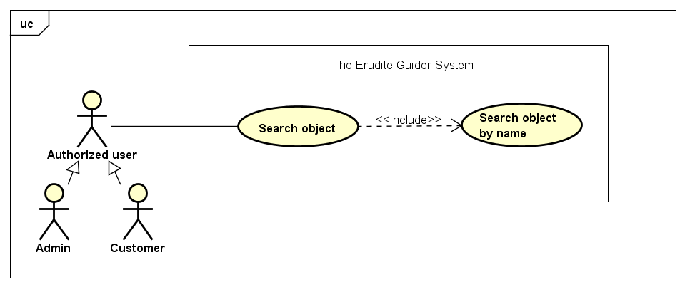

#### Search object by name

|  |  |  |  |
| --- | --- | --- | --- |
| Use Case ID: | UC-06-01 | | |
| Created By: | QuyetNH | Date Created: | 19/09/2016 |
| Primary Actor: | Authorized user | Secondary Actor: | Customer Admin |
| Trigger: | Authorized user needs to go to Object management section. | | |
| Description | To manage the list of object more easily, we create search function for authorized user in term of trace the objective they want to work on. "Tìm kiếm" is one of the basic functions easy to see because it is located in the first area of object management screen. Users just enter the name of the object you are looking for into the search box. Immediately after the finish typing the keyword and click search, a list of all the objects corresponding to the keywords will is displayed on the screen for users to reference. | | |
| Preconditions: | Authorized user needs to go to Object management section. | | |
| Post conditions: | List all result matches with keyword. | | |
| Normal Flow: | Search object by name:   1. Actor goes to Objects management screen. 2. Actor enter object’s name that want search. 3. Actor click on “Tìm kiếm” button. | | |
| Alternative Flows: | N/A | | |
| Exceptions: | N/A | | |
| Priority: | Medium | | |
| Frequency of Use: | High | | |
| Business Rules: | B46 | | |
| Other Information: | N/A | | |
| Assumptions | N/A | | |

### Request management

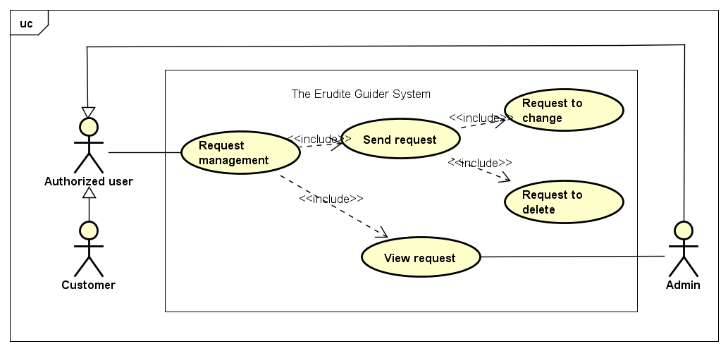

#### Send request

##### Request to change

|  |  |  |  |
| --- | --- | --- | --- |
| Use Case ID: | UC-07-01 | | |
| Created By: | QuyetNH | Date Created: | 19/09/2016 |
| Primary Actor: | Authorized user | Secondary Actor: | Customer |
| Trigger: | Click on dropt down menu and select “Yêu cầu sửa” option. | | |
| Description | When an object’s information in Pending status, you can directly edit it if necessary. However, for those in Active status, if want to change its information, you have to send a request to notify system that you want to impacts on an online object of the system. Purpose here is help both System and Museum side control their information and object as well. After your request is sent, Admin will receive it and verify to see that request is valid or not. In case of valid request and be approved by Admin, the corresponding object’s information will be change status form Active to Pending. Now, you can treat it as a Pending object and edit as above. | | |
| Preconditions: | Have object’s information in Active status in the list. | | |
| Post conditions: | Object’s status change from Active to Pending. | | |
| Normal Flow: | Request to change object’ information:   1. Customer login to *The Erudite Guider* and click on “Quản lý hiện vật” section on left navigation bar. 2. Customer click on “Gửi yêu cầu” dropt down menu of corresponding object. 3. Select “Yêu cầu sửa” option. 4. Enter reason in “Lý do gửi yêu cầu” text field. 5. Click on “Gửi yêu cầu” button to finish action. | | |
| Alternative Flows: | Customer can click “Đóng” button to cancel sending request. | | |
| Exceptions: | N/A | | |
| Priority: | High | | |
| Frequency of Use: | High | | |
| Business Rules: | B47 | | |
| Other Information: | N/A | | |
| Assumptions | N/A | | |

##### Request to delete

|  |  |  |  |
| --- | --- | --- | --- |
| Use Case ID: | UC-07-02 | | |
| Created By: | QuyetNH | Date Created: | 19/09/2016 |
| Primary Actor: | Authorized user | Secondary Actor: | Customer |
| Trigger: | Click on dropt down menu and select “Yêu cầu xóa” option. | | |
| Description | When an object’s information in Pending status, you can directly edit it if necessary but cannot delete. Direct deleting even more impossible for object’s information in Active status. Whenever you want to remove an object in your list, you just need to send a request to delete to server similar to request to change above. In case of valid request and be approved by Admin, the corresponding object’s information will be remove from your list immediately. | | |
| Preconditions: | Have object’s information in Active/ Pending status in the list. | | |
| Post conditions: | The corresponding object will be removed from your list. | | |
| Normal Flow: | Request to delete object:   1. Customer login to *The Erudite Guider* and click on “Quản lý hiện vật” section on left navigation bar. 2. Customer click on “Gửi yêu cầu” dropt down menu of corresponding object 3. Select “Yêu cầu xóa” option. 4. Enter reason in “Lý do gửi yêu cầu” text field. 5. Click on “Gửi yêu cầu” button to finish action. | | |
| Alternative Flows: | Customer can click “Đóng” button to cancel sending request. | | |
| Exceptions: | N/A | | |
| Priority: | High | | |
| Frequency of Use: | High | | |
| Business Rules: | B47 | | |
| Other Information: | N/A | | |
| Assumptions | N/A | | |

#### View request

|  |  |  |  |
| --- | --- | --- | --- |
| Use Case ID: | UC-07-03 | | |
| Created By: | QuyetNH | Date Created: | 19/09/2016 |
| Primary Actor: | Authorized user | Secondary Actor: | Customer  Admin |
| Trigger: | Authorized user needs to access to *The Erudite Guider* and then go to “Yêu cầu xử lý”. | | |
| Description | After created request to change object’s information of your museum, if you want to manage your requests, you just go to “Yêu cầu xử lý” on *The Erudite Guider*. This section has a list of request those you just created and waiting for approving from system admin. Base on the list, you can review detail of your requests such as: what kind of request, which object do you want to work on in each request, reason for sending request, when request is created … | | |
| Preconditions: | Authorized user has at least one valid request. | | |
| Post conditions: | List of request is displayed. | | |
| Normal Flow: | View request:   1. Customer login to *The Erudite Guider* 2. Click on “Yêu cầu xử lý” section on left navigation bar. | | |
| Alternative Flows: | N/A | | |
| Exceptions: | N/A | | |
| Priority: | High | | |
| Frequency of Use: | High | | |
| Business Rules: | B48 | | |
| Other Information: | N/A | | |
| Assumptions | N/A | | |

### Museum profile management

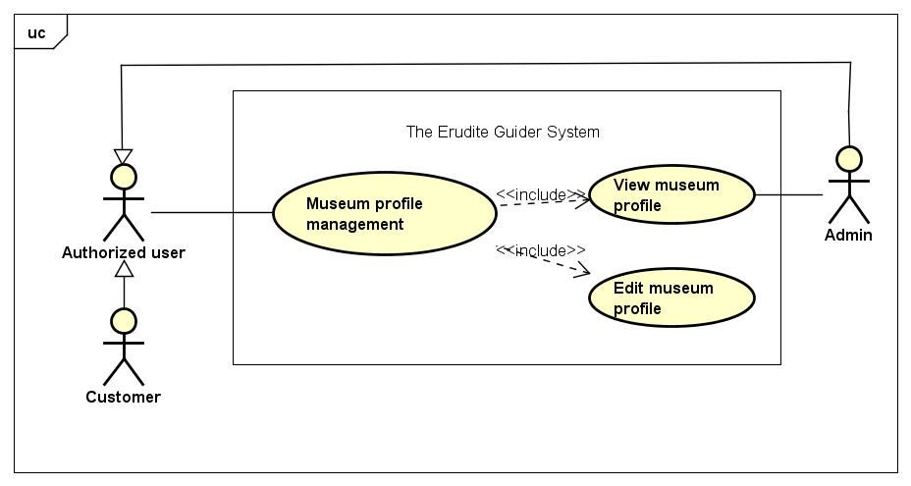

#### View museum profile

|  |  |  |  |
| --- | --- | --- | --- |
| Use Case ID: | UC-08-01 | | |
| Created By: | QuyetNH | Date Created: | 19/09/2016 |
| Primary Actor: | Authorized user | Secondary Actor: | Customer  Admin |
| Trigger: | Customer clicks “Thông tin bảo tàng” on left navigation bar.  Admin clicks museum’s name. | | |
| Description | Museum’s information is an important part of our system because it helps us identify our customer. You are a museum and using our services. Therefore, your museum’s information needs to be managed frequently and closely. We created a friendly environment to help use easily view the information of your museum. This function also contribute to help your enterprise do brand promotion. | | |
| Preconditions: | Authorized user login to system successfully. | | |
| Post conditions: | All of museum’s information will be displayed. | | |
| Normal Flow: | View museum profile for customer:  1. Customer login to *The Erudite Guider* and click on “Thông tin bảo tàng” section on left navigation bar. 2. All of museum’s information will be displayed.  View museum profile for admin:  1. Admin login to *The Erudite Guider* and click on “Quản lý tài khoản” section on left navigation bar. 2. Admin click on museum’s name. 3. All of museum’s information will be displayed. | | |
| Alternative Flows: | N/A | | |
| Exceptions: | N/A | | |
| Priority: | Medium | | |
| Frequency of Use: | Medium | | |
| Business Rules: | N/A | | |
| Other Information: | N/A | | |
| Assumptions | N/A | | |

#### Edit museum profile

|  |  |  |  |
| --- | --- | --- | --- |
| Use Case ID: | UC-08-02 | | |
| Created By: | QuyetNH | Date Created: | 19/09/2016 |
| Primary Actor: | Authorized user | Secondary Actor: | Customer |
| Trigger: | Authorized go to “Thông tin bảo tàng” and click “Sửa” button. | | |
| Description | Museum’s information is an important part of our system because it helps us identify our customer. You are a museum and using our services. Therefore, your museum’s information needs to be managed frequently and closely. We created a friendly environment to help use easily view the information of your museum. This function also contribute to help your enterprise do brand promotion. However, some information can be change over time and you can update it easily on our website just by click on “Sửa” button. | | |
| Preconditions: | Authorized user login to system successfully. | | |
| Post conditions: | Corresponding museum’s information will be changed. | | |
| Normal Flow: | Edit museum profile:   1. Customer login to *The Erudite Guider* and click on “Thông tin bảo tàng” section on left navigation bar. 2. All of museum’s information will be displayed. 3. Enter corresponding information that you want to change. 4. Click “Lưu” button. 5. Click “Xác nhận” button on popup window. | | |
| Alternative Flows: | Customer can click “Trở lại” button to cancel changing information or “Từ chối” button on popup window. | | |
| Exceptions: | N/A | | |
| Priority: | High | | |
| Frequency of Use: | Medium | | |
| Business Rules: | B10, B11, B12, B13, B14, B15, B16, B17, B18, B19, B20, B21, B22, B23, B24, B25 | | |
| Other Information: | N/A | | |
| Assumptions | N/A | | |

### User profile management

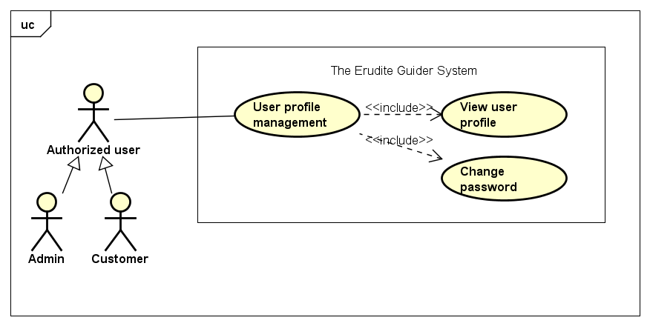

#### View user profile

|  |  |  |  |
| --- | --- | --- | --- |
| Use Case ID: | UC-09-01 | | |
| Created By: | QuyetNH | Date Created: | 11/10/2016 |
| Primary Actor: | Authorized user | Secondary Actor: | Customer  Admin |
| Trigger: | Authorized user needs to access to The Erudite Guider system. | | |
| Description | Authorized user can view the profile to know how the information about their account is stored on the system. | | |
| Preconditions: | Authorized user has valid account on system. | | |
| Post conditions: | User profile will be displayed. | | |
| Normal Flow: | View user profile:   1. Actor clicks on email display on navigation bar. 2. Actor clicks on “Thông tin tài khoản” in dropdown menu. 3. User profile will be displayed. | | |
| Alternative Flows: | N/A | | |
| Exceptions: | N/A | | |
| Priority: | Medium | | |
| Frequency of Use: | Medium | | |
| Business Rules: | N/A | | |
| Other Information: | N/A | | |
| Assumptions | N/A | | |

#### Change password

|  |  |  |  |
| --- | --- | --- | --- |
| Use Case ID: | UC-09-02 | | |
| Created By: | QuyetNH | Date Created: | 11/10/2016 |
| Primary Actor: | Authorized user | Secondary Actor: | Customer  Admin |
| Trigger: | Authorized user needs to access to The Erudite Guider system. | | |
| Description | You already have an account on The Erudite Guider system. When you register an account, you enter your account information in the form. For some reason you want to use change your information on your account profile (login email, password).  Login email is the official email of museum, therefore, if you want to change this field, please re-check at “Edit museum profile” UC.  Password is the mandatory requirement to help you login to The Erudite Guider system. In addition it is help protect your accounts from those with malicious intent. You want to change the password because you fear someone know or you do not trust who already know your password or you simply want to replace one password to remember. This function will help you easily do that.  After successfully changing, your account information (password) will be updated as you want. | | |
| Preconditions: | Authorized user needs to access to The Erudite Guider system. | | |
| Post conditions: | Password will be updated. | | |
| Normal Flow: | Change password:  1. Actor clicks on email display on navigation bar. 2. Actor clicks on “Thông tin tài khoản” in dropdown menu. 3. User profile will be displayed. 4. Click “Sửa” button. 5. Enter old password. 6. Enter new password. 7. Enter retype password. 8. Click “Lưu” button. | | |
| Alternative Flows: | Customer want to cancel changing profile:   1. At step 7, user click on “Trở lại” button 2. The changing is cancel and old information will be kept. | | |
| Exceptions: | N/A | | |
| Priority: | Medium | | |
| Frequency of Use: | Low | | |
| Business Rules: | B5, B6, B7, B8, B9 | | |
| Other Information: | N/A | | |
| Assumptions | N/A | | |

### Guest’s request management

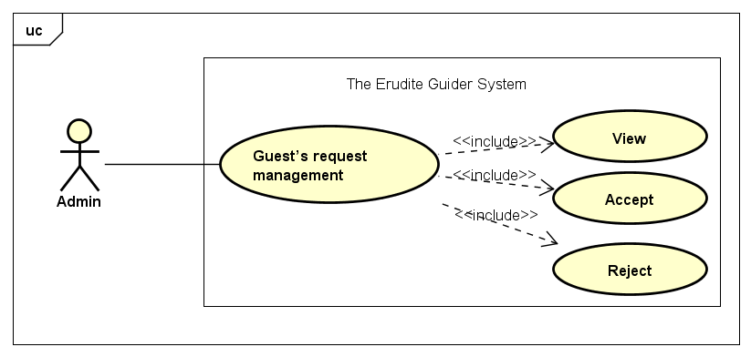

#### View

|  |  |  |  |
| --- | --- | --- | --- |
| Use Case ID: | UC-10-01 | | |
| Created By: | QuyetNH | Date Created: | 11/10/2016 |
| Primary Actor: | Admin | Secondary Actor: | N/A |
| Trigger: | Click “Yêu cầu từ khách” | | |
| Description | As mentioned above, when a museum want to use our service but they just are our guest because they cannot login to system. If want to become a member, guest need to register. Then, guest’s request will be sent to admin. Admin is the important actor to ensure all requests are managed include of requests from guest. | | |
| Preconditions: | Admin login to The Erudite Guider system successfully | | |
| Post conditions: | Display a list of requests from guests | | |
| Normal Flow: | View list of Guest’s request:  1. Admin login to *The Erudite Guider* system. 2. Click “Yêu cầu từ khách” on navigation bar. | | |
| Alternative Flows: | N/A | | |
| Exceptions: | N/A | | |
| Priority: | High | | |
| Frequency of Use: | High | | |
| Business Rules: | N/A | | |
| Other Information: | N/A | | |
| Assumptions | N/A | | |

#### Accept

|  |  |  |  |
| --- | --- | --- | --- |
| Use Case ID: | UC-10-02 | | |
| Created By: | QuyetNH | Date Created: | 11/10/2016 |
| Primary Actor: | Admin | Secondary Actor: | N/A |
| Trigger: | “Yêu cầu từ khách” Screen | | |
| Description | As mentioned above, when a museum want to use our service but they only are our guest because they cannot login to system. If want to become a member, guest need to register. Then, guest’s request will be sent to admin. Admin is the important actor to ensure all requests are managed. After receive guest’s request, admin use his operational skills to verify and determine either accept the request or not. If guest’s information in request form is valid, admin can accept by click on accept sign (✓). Then, account will be generated immediately and notify to guest (now became customer). | | |
| Preconditions: | Valid guest’ request. | | |
| Post conditions: | Generate a customer’s account and notification will be sent automatically to registered email. | | |
| Normal Flow: | Accept:  1. Admin login to *The Erudite Guider* system. 2. Click “Yêu cầu từ khách” on navigation bar. 3. Admin verify guest’s request. 4. Click on accept sign (✓). | | |
| Alternative Flows: | N/A | | |
| Exceptions: | N/A | | |
| Priority: | High | | |
| Frequency of Use: | High | | |
| Business Rules: | B49, B50, B62 | | |
| Other Information: | N/A | | |
| Assumptions | N/A | | |

#### Reject

|  |  |  |  |
| --- | --- | --- | --- |
| Use Case ID: | UC-10-03 | | |
| Created By: | QuyetNH | Date Created: | 11/10/2016 |
| Primary Actor: | Admin | Secondary Actor: | N/A |
| Trigger: | “Yêu cầu từ khách” Screen | | |
| Description | As mentioned above, when a museum want to use our service but they only are our guest because they cannot login to system. If want to become a member, guest need to register. Then, guest’s request will be sent to admin. Admin is the important actor to ensure all requests are managed. After receive guest’s request, admin use his operational skills to verify and determine either accept the request or not. If guest’s information in request form is invalid, admin can reject by click on reject sign (x). Then, guest will be notified reason why the request be rejected. | | |
| Preconditions: | Admin login to The Erudite Guider system successfully | | |
| Post conditions: | Notification will be sent automatically to registered email. | | |
| Normal Flow: | Reject:  1. Admin login to *The Erudite Guider* system. 2. Click “Yêu cầu từ khách” on navigation bar. 3. Admin verify guest’s request. 4. Click on reject sign (x). | | |
| Alternative Flows: | N/A | | |
| Exceptions: | N/A | | |
| Priority: | High | | |
| Frequency of Use: | High | | |
| Business Rules: | B49, B50, B62 | | |
| Other Information: | N/A | | |
| Assumptions | N/A | | |

### Customer’s request management

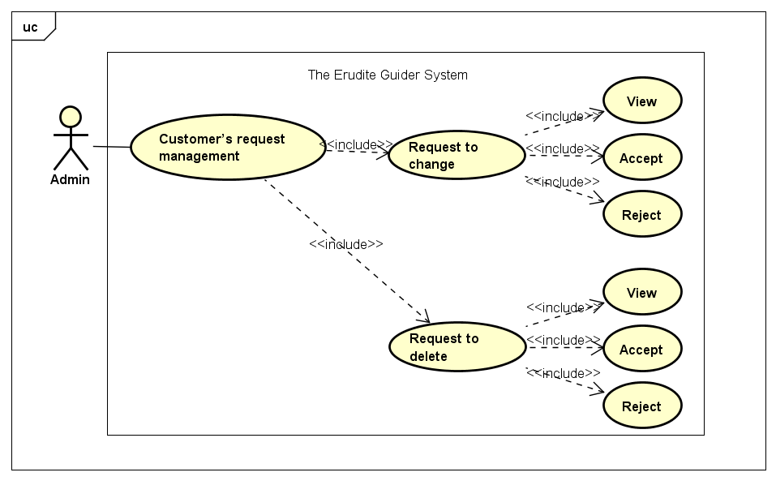

#### Request to change

##### View

|  |  |  |  |
| --- | --- | --- | --- |
| Use Case ID: | UC-11-01 | | |
| Created By: | QuyetNH | Date Created: | 11/10/2016 |
| Primary Actor: | Administrator | Secondary Actor: | N/A |
| Trigger: | Administrator needs to access to The Erudite Guider system. | | |
| Description | When customers want to change the information of the objects are in the Active state, or when they want to transform from object’s Available state to object’s Active state (special case is when customer upload new object and tick in Available status, it is considered as a request to change status from Available to Active), they will have to send a request to admin to change the status of object from Active to Pending or from Available to Active. Then, admin can view all requests from the museums at item "Quản lý bảo tàng". In each museum, admin can view all the requests by clicking on the "Danh sách yêu cầu" at each respective museum. Thence, admin evaluate and handle each customer's request base on request’s content such as name of object, current status of object, reasons, ... | | |
| Preconditions: | Administrator has valid account on system. | | |
| Post conditions: | List of change object’s status request is displayed | | |
| Normal Flow: | View list of change object’s status request:   1. Administrator access in to The Erudite Guider system. 2. Click “Quản lý bảo tàng”. 3. Click “Danh sách yêu cầu” button. 4. List of request from customer will be displayed. | | |
| Alternative Flows: | N/A | | |
| Exceptions: | N/A | | |
| Priority: | Medium | | |
| Frequency of Use: | High | | |
| Business Rules: | B48 | | |
| Other Information: | N/A | | |
| Assumptions | N/A | | |

##### Accept

|  |  |  |  |
| --- | --- | --- | --- |
| Use Case ID: | UC-11-02 | | |
| Created By: | QuyetNH | Date Created: | 11/10/2016 |
| Primary Actor: | Administrator | Secondary Actor: | N/A |
| Trigger: | Administrator needs to access to The Erudite Guider system. | | |
| Description | After receiving and evaluating requests from customers, admin can accept easily that request by click on the "Chấp nhận" button in a prompt window displayed after clicking the "Xử lý yêu cầu" button of each request. This means that customer’s request had been approved and system will notify this approval to customer's account. | | |
| Preconditions: | Administrator has valid account on system. | | |
| Post conditions: | Change object’s status request is accepted and notification will be sent automatically to customer’s email. | | |
| Normal Flow: | Accept change object’s status request:   1. Administrator access in to The Erudite Guider system. 2. Click “Quản lý bảo tàng”. 3. Click “Danh sách yêu cầu” button to display list of requests. 4. Administrator verify request. 5. Click “Xử lý yêu cầu” button of each request. 6. Click "Chấp nhận" button to accept the request. | | |
| Alternative Flows: | At step 5, Administrator click “Đóng” button. | | |
| Exceptions: | N/A | | |
| Priority: | Medium | | |
| Frequency of Use: | High | | |
| Business Rules: | B48, B49, B51, B62 | | |
| Other Information: | N/A | | |
| Assumptions | N/A | | |

##### Reject

|  |  |  |  |
| --- | --- | --- | --- |
| Use Case ID: | UC-11-03 | | |
| Created By: | QuyetNH | Date Created: | 11/10/2016 |
| Primary Actor: | Administrator | Secondary Actor: | N/A |
| Trigger: | Administrator needs to access to The Erudite Guider system. | | |
| Description | After receiving and evaluating requests from customers, admin can accept easily that request by click on the "Từ chối" button in a prompt window displayed after clicking the "Xử lý yêu cầu" button of each request. This means that customer’s request had been denied and system will notify this to customer's account. | | |
| Preconditions: | Administrator has valid account on system. | | |
| Post conditions: | Change object’s status request is rejected and notification will be sent automatically to customer’s email. | | |
| Normal Flow: | Reject change object’s status request:   1. Administrator access in to The Erudite Guider system. 2. Click “Quản lý bảo tàng”. 3. Click “Danh sách yêu cầu” button to display list of requests. 4. Administrator verify request. 5. Click “Xử lý yêu cầu” button of each request. 6. Click "Từ chối" button to accept the request. | | |
| Alternative Flows: | At step 5, Administrator click “Đóng” button. | | |
| Exceptions: | N/A | | |
| Priority: | Medium | | |
| Frequency of Use: | High | | |
| Business Rules: | B48, B49, B51, B62 | | |
| Other Information: | N/A | | |
| Assumptions | N/A | | |

#### Request to delete

##### View

|  |  |  |  |
| --- | --- | --- | --- |
| Use Case ID: | UC-11-04 | | |
| Created By: | QuyetNH | Date Created: | 11/10/2016 |
| Primary Actor: | Administrator | Secondary Actor: | N/A |
| Trigger: | Administrator needs to access to The Erudite Guider system. | | |
| Description | When customers want to delete the information of the objects are in The Erudite Guider system, no matter those objects are in Pending, Available or Active status, they will have to send a request to admin. Then, admin can view all requests from the museums at item "Quản lý bảo tàng". In each museum, admin can view all the requests by clicking on the "Danh sách yêu cầu" at each respective museum. Thence, admin evaluate and handle each customer's request base on request’s content such as name of object, current status of object, reasons, ... | | |
| Preconditions: | Administrator has valid account on system. | | |
| Post conditions: | List of delete object’s status request is displayed | | |
| Normal Flow: | View list of delete object’s status request:   1. Administrator access in to The Erudite Guider system. 2. Click “Quản lý bảo tàng”. 3. Click “Danh sách yêu cầu” button. 4. Administrator verify delete object’s information request. | | |
| Alternative Flows: | N/A | | |
| Exceptions: | N/A | | |
| Priority: | Medium | | |
| Frequency of Use: | High | | |
| Business Rules: | B48 | | |
| Other Information: | N/A | | |
| Assumptions | N/A | | |

##### Accept

|  |  |  |  |
| --- | --- | --- | --- |
| Use Case ID: | UC-11-05 | | |
| Created By: | QuyetNH | Date Created: | 11/10/2016 |
| Primary Actor: | Administrator | Secondary Actor: | N/A |
| Trigger: | Administrator needs to access to The Erudite Guider system. | | |
| Description | In the process of managing the objects on the system, sometimes customers want to remove objects are in the Active state. Meanwhile, similar the change of the status of objects, the customers will create a deleting request to the system. After receiving this request, Admin will verify and accept this request like requests to change object's status above. | | |
| Preconditions: | Administrator has valid account on system. | | |
| Post conditions: | Delete object’s status request is accepted and notification will be sent automatically to customer’s email. | | |
| Normal Flow: | Accept object deleting request:   1. Administrator access in to The Erudite Guider system. 2. Click “Quản lý bảo tàng”. 3. Click “Danh sách yêu cầu” button to display list of requests. 4. Administrator verify request. 5. Click “Xử lý yêu cầu” button of each request. 6. Click "Chấp nhận" button to accept the request. | | |
| Alternative Flows: | At step 5, Administrator click “Đóng” button. | | |
| Exceptions: | N/A | | |
| Priority: | Medium | | |
| Frequency of Use: | High | | |
| Business Rules: | B48, B49, B51 | | |
| Other Information: | N/A | | |
| Assumptions | N/A | | |

##### Reject

|  |  |  |  |
| --- | --- | --- | --- |
| Use Case ID: | UC-11-06 | | |
| Created By: | QuyetNH | Date Created: | 11/10/2016 |
| Primary Actor: | Administrator | Secondary Actor: | N/A |
| Trigger: | Administrator needs to access to The Erudite Guider system. | | |
| Description | In the process of managing the objects on the system, sometimes customers want to remove objects are in the Active state. Meanwhile, as well as the change of the status of objects, the customers will create a deleting request to the system. After receiving this request, Admin will verify and reject this request like requests to change object's status above. | | |
| Preconditions: | Administrator has valid account on system. | | |
| Post conditions: | Delete object’s status request is rejected and notification will be sent automatically to customer’s email. | | |
| Normal Flow: | Reject object deleting request:   1. Administrator access in to The Erudite Guider system. 2. Click “Quản lý bảo tàng”. 3. Click “Danh sách yêu cầu” button to display list of requests. 4. Administrator verify request. 5. Click “Xử lý yêu cầu” button of each request. 6. Click "Từ chối" button to accept the request. | | |
| Alternative Flows: | At step 5, Administrator click “Đóng” button. | | |
| Exceptions: | N/A | | |
| Priority: | Medium | | |
| Frequency of Use: | High | | |
| Business Rules: | B48, B49, B51 | | |
| Other Information: | N/A | | |
| Assumptions | N/A | | |

### Display list of museum

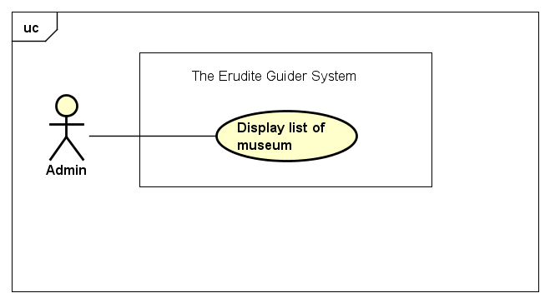

|  |  |  |  |
| --- | --- | --- | --- |
| Use Case ID: | UC-12-01 | | |
| Created By: | QuyetNH | Date Created: | 11/10/2016 |
| Primary Actor: | Administrator | Secondary Actor: | N/A |
| Trigger: | Click on “Quản lý bảo tàng” on left navigation bar | | |
| Description | Admin is able to view the entire list of museums which are using services of the system. This ensures that admin is active in manage museum and easy to manage requests as well as objects of each museum in the system. | | |
| Preconditions: | Administrator has valid account on system. | | |
| Post conditions: | List of museum is displayed | | |
| Normal Flow: | View list of museum:   1. Administrator access in to The Erudite Guider system. 2. Click “Quản lý bảo tàng”. 3. View list of museum is displayed in the screen. | | |
| Alternative Flows: | N/A | | |
| Exceptions: | N/A | | |
| Priority: | Medium | | |
| Frequency of Use: | High | | |
| Business Rules: | B52 | | |
| Other Information: | N/A | | |
| Assumptions | N/A | | |

### Account management

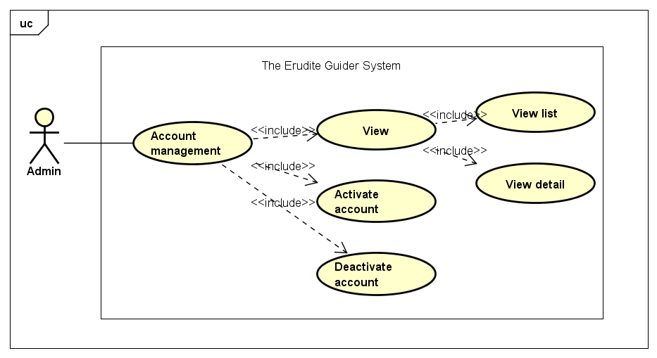

#### View

##### View list

|  |  |  |  |
| --- | --- | --- | --- |
| Use Case ID: | UC-13-01 | | |
| Created By: | QuyetNH | Date Created: | 11/10/2016 |
| Primary Actor: | Administrator | Secondary Actor: | N/A |
| Trigger: | Administrator needs to access to The Erudite Guider system. | | |
| Description | Admin have permission to view all of valid accounts those was accepted to working on the system. | | |
| Preconditions: | Administrator accepts to the system successfully. | | |
| Post conditions: | List of valid account is displayed | | |
| Normal Flow: | View list of valid account:   1. Administrator access in to The Erudite Guider system. 2. Click “Quản lý tài khoản” on left navigation bar. 3. View list of valid account is displayed in the screen. | | |
| Alternative Flows: | N/A | | |
| Exceptions: | N/A | | |
| Priority: | Medium | | |
| Frequency of Use: | High | | |
| Business Rules: | B53, B54 | | |
| Other Information: | N/A | | |
| Assumptions | N/A | | |

##### View detail

|  |  |  |  |
| --- | --- | --- | --- |
| Use Case ID: | UC-13-02 | | |
| Created By: | QuyetNH | Date Created: | 11/10/2016 |
| Primary Actor: | Administrator | Secondary Actor: | N/A |
| Trigger: | Administrator needs to access to The Erudite Guider system. | | |
| Description | Admin have permission to view all of valid accounts those was accepted to working on the system. Moreover, admin can also see detail of chosen account. | | |
| Preconditions: | Administrator accepts to the system successfully. | | |
| Post conditions: | Detail of chosen account is displayed | | |
| Normal Flow: | View detail account:   1. Administrator access in to The Erudite Guider system. 2. Click “Quản lý tài khoản”. 3. View list of valid account is displayed in the screen. 4. Detail of every single account also is displayed. 5. Admin can also click on “Chuyển trạng thái” button to see more information about both customer account and corresponding museum. | | |
| Alternative Flows: | N/A | | |
| Exceptions: | N/A | | |
| Priority: | Medium | | |
| Frequency of Use: | High | | |
| Business Rules: | B53, B54 | | |
| Other Information: | N/A | | |
| Assumptions | N/A | | |

#### Deactivate account

|  |  |  |  |
| --- | --- | --- | --- |
| Use Case ID: | UC-13-03 | | |
| Created By: | QuyetNH | Date Created: | 11/10/2016 |
| Primary Actor: | Administrator | Secondary Actor: | N/A |
| Trigger: | Administrator needs to access to The Erudite Guider system. | | |
| Description | When a museum, which is being the system’s customers want to stop using service of the system or the customers using the service is expiry, Admin can deactivate that customer’s account. And as the same time, the entire museum's objects will no longer able to be displayed when visitors use the application while they are visiting that museum. | | |
| Preconditions: | Administrator has valid account on system. | | |
| Post conditions: | The museum that is considered is deactivated. | | |
| Normal Flow: | Deactivate Museum:   1. Administrator access in to The Erudite Guider system. 2. Click “Quản lý tài khoản”. 3. View list of valid account is displayed in the screen. 4. See detail of chosen account as well. 5. Click on “Chuyển trạng thái” button to deactivate account in active status. 6. Click on “Deactivate” radio button. 7. Click “Lưu thay đổi” button to save changing. | | |
| Alternative Flows: | Admin want to cancel deactivate account:  At step 7, user does not click on “Lưu thay đổi” button and go back museum list. | | |
| Exceptions: | N/A | | |
| Priority: | Medium | | |
| Frequency of Use: | High | | |
| Business Rules: | B55 | | |
| Other Information: | N/A | | |
| Assumptions | N/A | | |

#### Activate account

|  |  |  |  |
| --- | --- | --- | --- |
| Use Case ID: | UC-13-04 | | |
| Created By: | QuyetNH | Date Created: | 11/10/2016 |
| Primary Actor: | Administrator | Secondary Actor: | N/A |
| Trigger: | Administrator needs to access to The Erudite Guider system. | | |
| Description | When the museum is in de- active status want to continue using the system's service, admin can activate the account of that museum. This means visitors can use the app to watch the information of objects when they visit it again. | | |
| Preconditions: | Administrator has valid account on system. | | |
| Post conditions: | The museum that is considered is deactivated. | | |
| Normal Flow: | Deactivate Museum:   1. Administrator access in to The Erudite Guider system. 2. Click “Quản lý tài khoản”. 3. View list of valid account is displayed in the screen. 4. See detail of chosen account as well. 5. Click on “Chuyển trạng thái” button to activate account in de-active status. 6. Click on “Activate” radio button. 7. Click “Lưu thay đổi” button to save changing. | | |
| Alternative Flows: | Admin want to cancel activate account:  At step 7, user does not click on “Lưu thay đổi” button and go back museum list. | | |
| Exceptions: | N/A | | |
| Priority: | Medium | | |
| Frequency of Use: | High | | |
| Business Rules: | B56 | | |
| Other Information: | N/A | | |
| Assumptions | N/A | | |

### Add new Admin

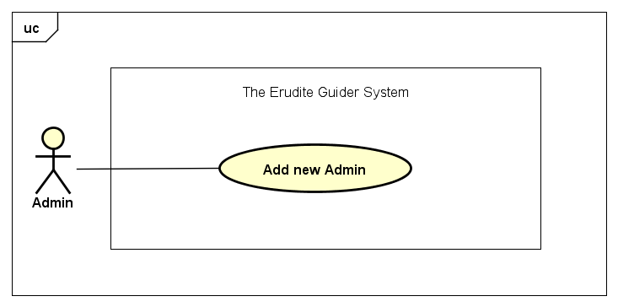

|  |  |  |  |
| --- | --- | --- | --- |
| Use Case ID: | UC-14-01 | | |
| Created By: | QuyetNH | Date Created: | 1/11/2016 |
| Primary Actor: | Administrator | Secondary Actor: | N/A |
| Trigger: | Click on “Thêm admin” button | | |
| Description | Administrator is an actor whose role is extremely important to the system because this actor have the highest permission level and is responsible for managing accounts, museum, request, … Therefore, work of the admin require a lot of effort and professionalism. Sometimes, admin have to do many things at the same time to operate system. To solve this problem, The Erudite Guider system allows admin can create more other admin to assign task and share responsibility. This function not only increases performance and productivity of the system, but it also generates a professional working environment hierarchy.  For creating a new admin account, user just need to has the right to go to account management of the system and provides require information. | | |
| Preconditions: | Access to system successfully | | |
| Post conditions: | New admin account is created | | |
| Normal Flow: | Add new Admin:   1. Administrator access in to The Erudite Guider system. 2. Click on “Quản lý tài khoản” on left navigation bar. 3. Click on “Thêm admin” button. 4. Enter require information. 5. Click “Tạo tài khoản” button to finish. | | |
| Alternative Flows: | At step 5, User click “Trở lại" button to cancel creating admin account. | | |
| Exceptions: | N/A | | |
| Priority: | Medium | | |
| Frequency of Use: | Low | | |
| Business Rules: | B1, B2, B3, B4, B5, B6, B7, B8, B9, B57, B58 | | |
| Other Information: | N/A | | |
| Assumptions | N/A | | |

### Sort Item

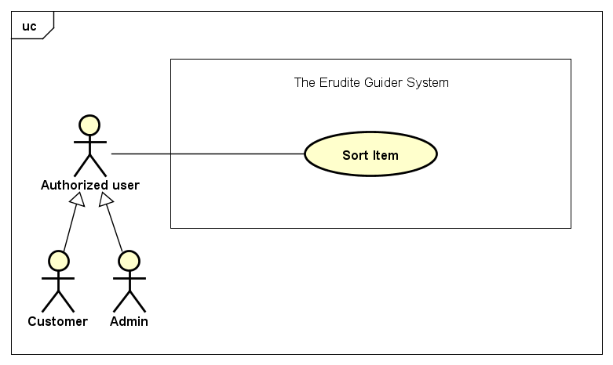

|  |  |  |  |
| --- | --- | --- | --- |
| Use Case ID: | UC-15-01 | | |
| Created By: | QuyetNH | Date Created: | 1/11/2016 |
| Primary Actor: | Authorized user | Secondary Actor: | Customer  Admin |
| Trigger: | Click on criteria that user want to sort on | | |
| Description | The Erudite Guider system provides user a friendly environment to help user manage items in the list of object when user works on it. Sorting will help user easy to order items by criteria that user want. For example, user is working on list of object of chosen museum, to order by Object’s name, user just need to clicks on sort icon beside “Tên hiện vật” to sort them by A to Z or vice versa. | | |
| Preconditions: | Access to system successfully | | |
| Post conditions: | Items are sorted by chosen criteria | | |
| Normal Flow: | Sort Item:   1. User access in to The Erudite Guider system. 2. Go to any list of item. 3. Click on criteria that user want to sort on. | | |
| Alternative Flows: | N/A | | |
| Exceptions: | List of item does not have item to sort | | |
| Priority: | Low | | |
| Frequency of Use: | Medium | | |
| Business Rules: | N/A | | |
| Other Information: | N/A | | |
| Assumptions | N/A | | |

### Visit Museum website

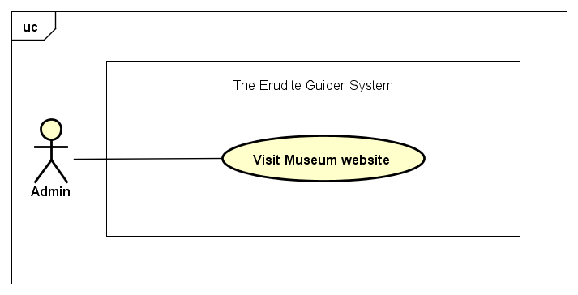

|  |  |  |  |
| --- | --- | --- | --- |
| Use Case ID: | UC-14-01 | | |
| Created By: | QuyetNH | Date Created: | 1/11/2016 |
| Primary Actor: | Administrator | Secondary Actor: | N/A |
| Trigger: | Click on “Thêm admin” button | | |
| Description | Admin have permission to view all of valid accounts those was accepted to working on the system. Moreover, admin can also see detail of chosen account. Among detail information of museum, Admin can see website correspond to each museum. This is official website and admin can click to go to this address to see more information of that museum. | | |
| Preconditions: | Access to system successfully | | |
| Post conditions: | Website address of museum will be accessed. | | |
| Normal Flow: | Add new Admin:   1. Administrator access in to The Erudite Guider system. 2. Click on “Quản lý tài khoản” on left navigation bar. 3. Click on museum’s website address link. | | |
| Alternative Flows: | N/A | | |
| Exceptions: | N/A | | |
| Priority: | Medium | | |
| Frequency of Use: | Low | | |
| Business Rules: | N/A | | |
| Other Information: | N/A | | |
| Assumptions | N/A | | |

### Choose museum

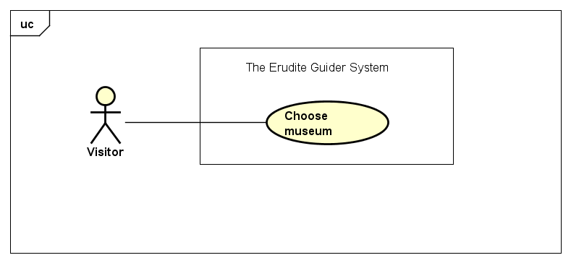

|  |  |  |  |
| --- | --- | --- | --- |
| Use Case ID: | UC-17-01 | | |
| Created By: | QuyetNH | Date Created: | 1/11/2016 |
| Primary Actor: | Visitor | Secondary Actor: | N/A |
| Trigger: | Run mobile application | | |
| Description | Mobile application is a very important part of *The Erudite Guider* system. Base on web application and database, mobile application use new image/ object recognition technology and augmented reality to help you can easily get information of museum’s object/ artifact. Before experience our special high- tech, you just need to run *The Erudite Guider* mobile application and chose the museum that you are visiting. By doing that, our system can identify the corresponding information/ content of the museum you want to use. | | |
| Preconditions: | Visitor runs *The Erudite Guider* mobile application successfully. | | |
| Post conditions: | List of museums is displayed. | | |
| Normal Flow: | Choose museum:  1. Visitor runs *The Erudite Guider* mobile application. 2. Choose corresponding museum that you are visiting. | | |
| Alternative Flows: | N/A | | |
| Exceptions: | N/A | | |
| Priority: | High | | |
| Frequency of Use: | High | | |
| Business Rules: | B59 | | |
| Other Information: | N/A | | |
| Assumptions | N/A | | |

### Object scanning- View Object content

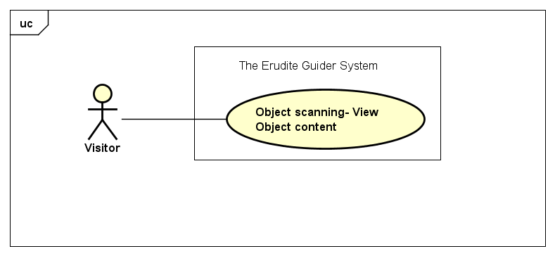

|  |  |  |  |
| --- | --- | --- | --- |
| Use Case ID: | UC-18-01 | | |
| Created By: | QuyetNH | Date Created: | 1/11/2016 |
| Primary Actor: | Visitor | Secondary Actor: | N/A |
| Trigger: | Finish choosing museum | | |
| Description | Mobile application is a very important part of *The Erudite Guider* system. Base on web application and database, mobile application use new image/ object recognition technology and augmented reality to help you can easily get information of museum’s object/ artifact. After choosing museum, mobile application will access you camera environment. Now you can use your camera to scan museum’s object to see the corresponding content is displayed on your screen. The special point here is the content can display in your camera environment. That is called augmented reality technology. | | |
| Preconditions: | Choose your museum. | | |
| Post conditions: | Access camera environment. | | |
| Normal Flow: | Object scanning- View Object content:  1. Visitor runs *The Erudite Guider* mobile application. 2. Choose corresponding museum that you are visiting. 3. Point your phone camera to museum’s object that you want to see. | | |
| Alternative Flows: | N/A | | |
| Exceptions: | N/A | | |
| Priority: | High | | |
| Frequency of Use: | High | | |
| Business Rules: | B60, B61 | | |
| Other Information: | N/A | | |
| Assumptions | N/A | | |

## System flowchart

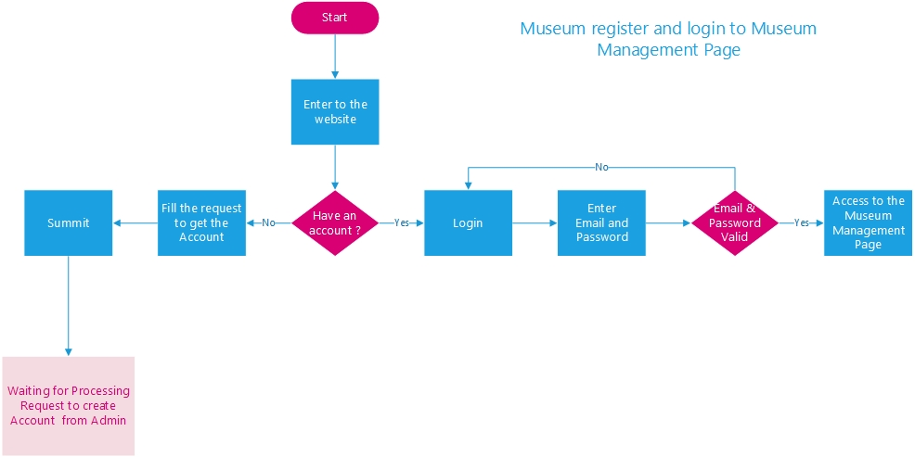

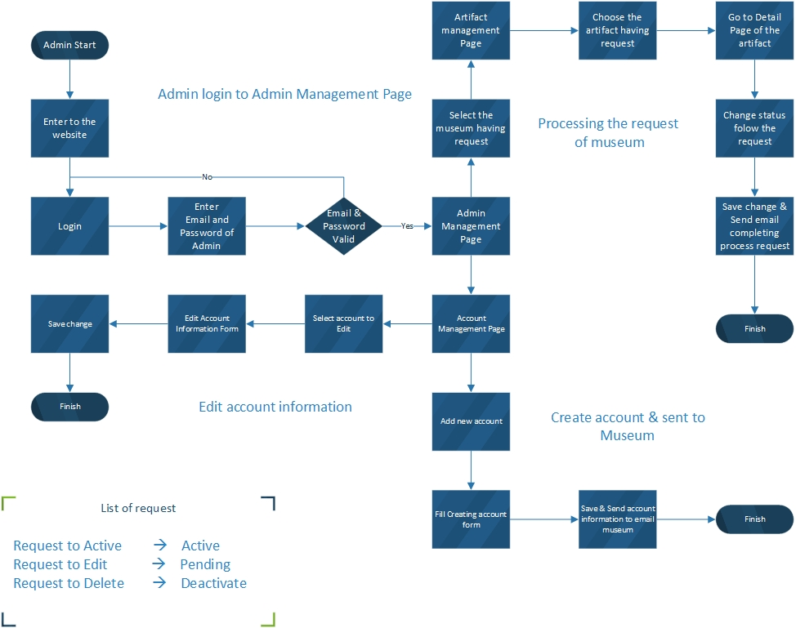

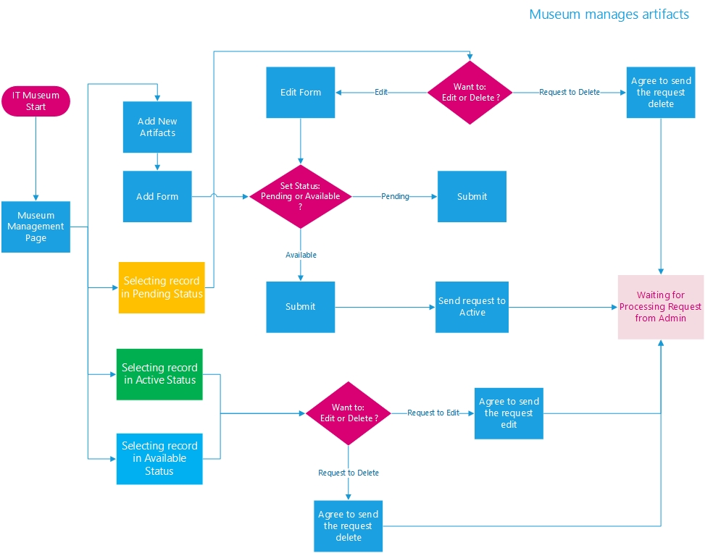

## Non-Functional Requirements

### Security

* Apply Authorize Attribute feature to the action methods.
* The security matrix is as the following table:

|  |  |  |  |  |  |
| --- | --- | --- | --- | --- | --- |
| Function | Guest | Visitor | Authorized Users | Customer | Admin |
| Register | ✓ |  |  |  |  |
| Log in |  |  | ✓ | ✓ | ✓ |
| Log out |  |  | ✓ | ✓ | ✓ |
| Get new password |  |  | ✓ | ✓ | ✓ |
| Object management |  |  | ✓ | ✓ |  |
| Search object by name |  |  | ✓ | ✓ | ✓ |
| Send request |  |  | ✓ | ✓ |  |
| View request |  |  | ✓ | ✓ | ✓ |
| View museum profile |  |  | ✓ | ✓ | ✓ |
| Edit museum profile |  |  | ✓ | ✓ |  |
| Choose museum |  | ✓ |  |  |  |
| Object scanning- View Object information |  | ✓ |  |  |  |

### Usability

* Easy to understand and use website without training. Museum only need a valid account and 1 click to manage their object.
* Friendly and modern GUI: Big size font text, Vietnamese language, simple layer item, visually color.
* Navigation bar is simple, little section.

### Reliability

* The output should avoid conflicting and misleading outputs when the inputs are confusing.
* Mean time to recover: In the case of failure, system should be able to recover within one day.
* Server have back-up method to make sure that if it have problem while running then all necessary data must be protected and restore as soon as possible.
* Server should be available 24/7 standby to serve user requests except the time of maintenance and upgrade.

### Performance

* Server response time is under 200 milliseconds.
* Send the result after searching in 3-5 seconds.// **out of scope**
* Write what you do.

### Maintainability

* The system is divided into separated modules.
* Output of project must include coding standards and naming convention documentations.
* The data should be easily to maintain over time. When update data, the source code does not need to be changed.
* Limit hard code as possible.

### Extendibility

Since nowadays a lot of people have at least one smartphone. So that, in the future we want to develop this as mobile application to more convenience when using our system while walk around the city. Moreover, if this website is success, we will be able to develop a larger system with extended scope to whole of Vietnam country.

## Database Requirements

